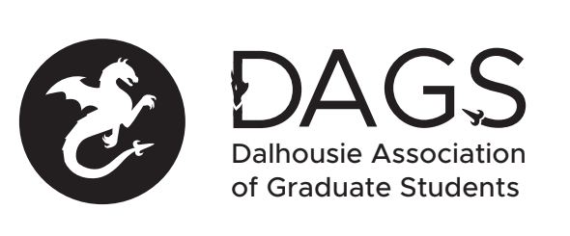

Local 113 of the Canadian Federation of Students
Council Meeting: Thursday, January 31st at 5:30 PM – DAGS Office– SUB, 4th Floor
- CALL TO ORDER:
- Present: Kaitlynne Lowe, Maxine Kirshenbaum, Adebayo Majeckolagebe, Subin Rajendran, Jay Patel, Liam Bindle, Sarah Vela
- APPROVAL OF AGENDA
  - Motion to be approved: (18-EXEC-96) - Cutmore/Patel - carried
- APPROVAL OF MINUTES (Table to next meeting) – Motion to table until next meeting (18-EXEC-97) – Rajendran/Patel - carried
- PRESENTATIONS AND CORRESPONDENCE
  - Information Without Boarders Conference Special Funding Grant Presentation
- NEW BUSINESS
  - Grants approval
    - Information without Boarders- (18-EXEC-98) – Rajendran/ Patel - carried
    - Motion to approve in omnibus- (18-EXEC-99) – Vela / Cutmore – carried
    - Motion to approve the following grants (18-EXEC-100) – Vela/ Cutmore – carried
      - MD Jahedul Alam
      - Mohammad Azad
- ANNOUNCEMENTS
  - Lunch and Learn Feb 15th
- ADJOURNMENT - (18-EXEC-101)
Minutes approved at meeting date: ______________
Moved by:____________
Seconded by:_____________

