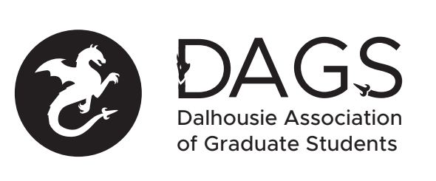

Local 113 of the Canadian Federation of Students
Council Meeting: Thursday, January 17th at 5:30 PM – Boardroom A – SUB
- CALL TO ORDER: 5:33pm
- Present: Kaitlynne Lowe, Maxine Kirshenbaum, Adebayo Majeckolagebe, Subin Rajendran, Sarah Vela, Jay Patel, Liam Bindle, Casper Macaulay, Beth Watson
- APPROVAL OF AGENDA
  - Motion to be approved: (18-EXEC-90) – Cutmore/ Patel – carried
- APPROVAL OF MINUTES – (18-EXEC-91) – Motion to table to next meeting -
- PRESENTATIONS AND CORRESPONDENCE
  - ACPA Special Funding Grant Presentation
  - Chemistry Special Funding Grant Presentation
  - International Travel Policy – International Centre
- RECEIPT OF REPORTS
  - President
  - Vice-President (Academic Affairs)
  - Vice-President (External Advocacy)
  - Vice-President (Finance and Operations)
- OLD BUSINESS
- NEW BUSINESS
  - Grants approval
    - Motion to be approved - ACPA Special Funding Grant (18-EXEC-92) – Kirshenbaum/Cutmore - carried
    - Motion to be approved - Chemistry Special Funding Grant (18-EXEC-93) – Patel/ Majeckolagebe carried
    - Motion to approve travel and professional development grants in omnibus (18-EXEC-94) – Cutmore/Kirshenbaum - carried
    - Motion to approve the following travel and professional development grant applications (18-EXEC-95) – Macaulay/Watson - carried
      - Jaclyn Kirstiuk
      - Aaron Yip
      - Melissa Spence
      - Lisa Hacket
      - Maria Delgado Aquije
      - Paulina Miller

- BUSINESS ARISING FROM REPORTS
- ANNOUNCEMENTS
- ADJOURNMENT(18-EXEC-95) – Cutmore/Patel - carried
Minutes approved at meeting date: ______________
Moved by:____________
Seconded by:_____________

