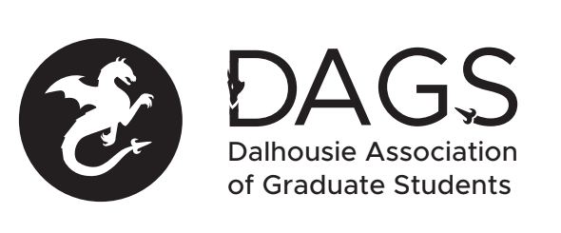

Local 113 of the Canadian Federation of Students
Council Meeting: Monday, July 20th at 3:00 PM – Via Microsoft Teams
- CALL TO ORDER
- APPROVAL OF SECRETARY
- PRESENT
- APPROVAL OF AGENDA
- APPROVAL OF MINUTES (June 26th)
- OLD BUSINESS
  - Election Update
- NEW BUSINESS
  - Approval of honoraria of DAGS board member
- ANNOUNCEMENTS
  - Office coordinator and financial matters.
  - COVID 19 fund.
- ADJOURNMENT
Minutes approved at meeting date: ______________
Moved by:____________
Seconded by:_____________

