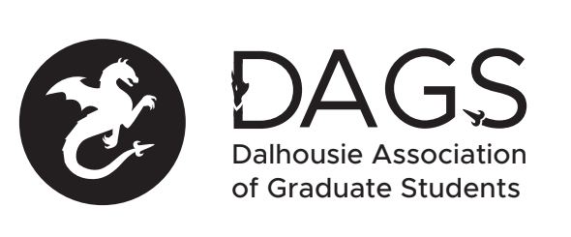

Local 113 of the Canadian Federation of Students
Council Meeting: Thursday, April 25th at 5:30 PM – DAGS Office– SUB, Room 418
- CALL TO ORDER:
- Present:
- APPROVAL OF AGENDA
  - Motion to be approved: (18-EXEC-)
- Presentations and Correspondence
  - Term Reports
    - President
    - VP Academic
    - VP External
    - VPFO
    - Director (Engineering)
    - Director (Science)
    - Director (Arts)
  - 2019-2020 Board Resignations
    - Martine Panzica
    - Hailie Tattrie
    - Kayla Preston
- NEW BUSINESS
  - Grants Policy Approval
  - Booking Policy Approval
  - Elections Policy Approval
  - HR Policy Approval
  - Grants Approval
  - Board Member Honoraria
    - VP Academic
    - VP External
    - VPFO
    - Director (Engineering)
    - Director (Science)
    - Director (Arts)
    - President
  - CRO Honoraria
- ANNOUNCEMENTS
  - FGS is hosting a half-day conference “Building a Positive Supervisory Relationship” which will explore the dynamics of the student-supervisor relationship and how they can be optimized. This event is for you whether you’re a new graduate student who wants to learn strategies and best practice or an experienced graduate student who wants to share what you’ve learned. Click here for more details and to RSVP for the event: http://ow.ly/7e3T50qtJg3
- ADJOURNMENT
Minutes approved at meeting date: ______________
Moved by:____________
Seconded by:_____________

