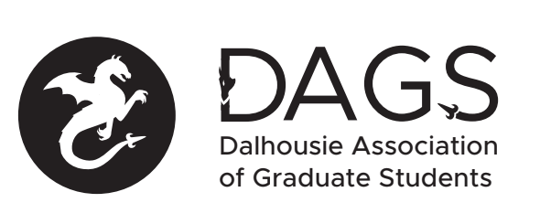

Local 113 of the Canadian Federation of Students
Council Meeting: Friday, October 9th at 12:00 PM – via Microsoft Teams
- CALL TO ORDER
- APPROVAL OF SECRETARY
- PRESENT
- APPROVAL OF AGENDA
- OLD BUSINESS
- NEW BUSINESS
  - Senate Caucus Updates
  - Society Updates (DAGSE)
  - Approvals for Research and Travel Grants / Honorariums
  - Member inputs on “Online Graduate Programming”
  - Appointments for vacant positions in DAGS
  - Ombudsperson Advisory Committee appointment (Strople’s Report)
  - Ad-hoc committee appointment (offline engagement committee)
- ANNOUNCEMENTS
  - DAGS COVID-19 Survey
- ADJOURNMENT
Minutes approved at meeting date: ______________
Moved by:____________
Seconded by:_____________

