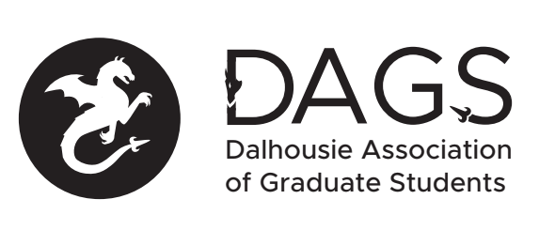

Local 113 of the Canadian Federation of Students
Council Meeting: Wednesday August 24th 3:00 PM, In-Person/Microsoft Teams
- CALL TO ORDER
- APPROVAL OF SECRETARY
- PRESENT
- APPROVAL OF AGENDA
- APPROVAL OF PREVIOUS DAGS COUNCIL MEETING MINUTES
- OLD BUSINESS
  - DAGS tabling idea updates
  - Fall AGM to ratify Governance Committee suggested revisions to constitution and bylaws, and to increase DAGS council honoraria amounts
- NEW BUSINESS
  - DAGS Executive Updates
  - DAGS Executive Retreat idea and budget
  - Office Coordinator interim hiring process update
  - DAGS Director application
  - Grant Approvals
    - Perri Tutelman’s Grant
    - Shannon Clemens’s Grants (2)
    - Mohammad Americanmatlob’s Grants (2)
    - Lydia Muyingo’s Grant
    - Emily Yeung’s Grant
    - Andrew Furlong’s Grant
    - Amy Irvine’s Grant

- ANNOUNCEMENTS
- ADJOURNMENT
Minutes approved at meeting date: ______________
Moved by:____________
Seconded by:_____________

