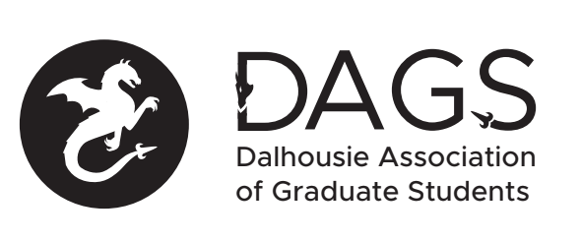

Local 113 of the Canadian Federation of Students
Council Meeting: Wednesday July 20th 3:00 PM, In-Person/Microsoft Teams
- CALL TO ORDER
- APPROVAL OF SECRETARY
- PRESENT
- APPROVAL OF AGENDA
- APPROVAL OF PREVIOUS DAGS COUNCIL MEETING MINUTES
- OLD BUSINESS
  - Community Representative positions/ Student Life Committee Update
    - Finalize descriptions of each position
    - Establish application requirements and timeline
    - Determine and approve honoraria
  - DAGS tabling idea
  - Possible second AGM to be held in the Fall to ratify Governance Committee suggested revisions to constitution and bylaws
- NEW BUSINESS
  - DAGS Executive Updates
  - CRA Update
  - Office Coordinator taking maternity and parental leave this Fall. Discuss interim coordinator hiring process
  - DAGS Grad Student Summer Event - discuss and approve timeline, regiatration form, and budget.
  - Grant Approvals
    - Hamzea Al-Jabouri
    - Kayle Dickson
    - Paria Siah Pour
    - Munsoo Choi
    - Jacob Campbell
    - Karen Tang (Pro Dev)
    - Karen Tang (Travel)

- ANNOUNCEMENTS
- ADJOURNMENT
Minutes approved at meeting date: ______________
Moved by:____________
Seconded by:_____________

