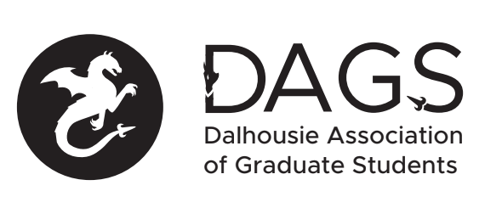

Local 113 of the Canadian Federation of Students
Council Meeting: Wednesday June 29th 3:00 PM, In-Person/Microsoft Teams
- CALL TO ORDER
- APPROVAL OF SECRETARY
- PRESENT
- APPROVAL OF AGENDA
- APPROVAL OF PREVIOUS DAGS COUNCIL MEETING MINUTES
- OLD BUSINESS
  - DAGS Finance Update
    - CRA account access and tax repayments
    - DSU debt repayment
  - Community Representative positions Update
    - Finalize descriptions of each position
    - Establish application requirements and timeline
- NEW BUSINESS
  - DAGS Executive Updates
  - DSU Representative Updates
  - Senate Caucus Updates
  - Governance Committee Updates
  - Office Coordinator Contract
  - Grant Approvals
    - Erik Nelson
    - Aleks Budarick
    - Ali Keyvandarian
    - Fatemeh Rahbari Manesh
    - Jianan Lin (Travel)
    - Jianan Lin (Professional Development)
    - Krista Collier-Jarvis
    - Mahya Ghaffari
    - Morteza Hajati
    - Sajjad Fanaee
- ANNOUNCEMENTS
- ADJOURNMENT
Minutes approved at meeting date: ______________
Moved by:____________
Seconded by:_____________

