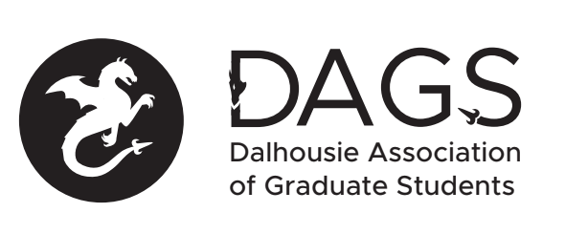

Local 113 of the Canadian Federation of Students
Council Meeting: Wednesday April 27th 3:00 PM, In-Person/Microsoft Teams
- CALL TO ORDER
- APPROVAL OF SECRETARY
- PRESENT
- APPROVAL OF AGENDA
- APPROVAL OF PREVIOUS DAGS COUNCIL MEETING MINUTES
- OLD BUSINESS
- NEW BUSINESS
  - DAGS Executive Updates. Year-end reports must be submitted in writing before final honoraria can be approved.
  - Students in Distress Grant Bill - detailed plan shared by Hari and Fallen
  - Budget and planning of AGM on May 11
  - Audit operation in DAGS - For operation transparency, consolidate individual officer's reports and expenses report and make them available in menu at DAGS website
  - Open table for discussion regarding the governance committee and inputs for potential revisions to bylaws
  - Election updates by CRO
  - Grant Approvals
    - Perri Tutelman
    - Nicole MacKenzie
    - Yvonne Brandelli
    - Julia Koppernaes
- ANNOUNCEMENTS
- ADJOURNMENT
Minutes approved at meeting date: ______________
Moved by:____________
Seconded by:_____________

