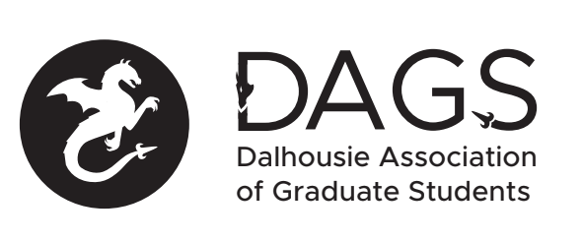

Local 113 of the Canadian Federation of Students
Council Meeting: Tuesday December 21st 3:00 PM via Microsoft Teams
- CALL TO ORDER 3:08 PM
Hari will chair the meeting (Hari/Pooyan)
- APPROVAL OF SECRETARY Office Coordinator (Hari/Pooyan)
- PRESENT:
Gabriella Luongo; Hariprashanth Deivasigamani - DAGS VPA; Pooyan Moradi - Director of Health and Medical Sciences; Mohammad Ramezani - DAGS VPFO; Michael Connolly; Office Coordinator.
- APPROVAL OF AGENDA (Hari/Gabriella)
- APPROVAL OF PREVIOUS DAGS COUNCIL MEETING MINUTES (Hari/Pooyan)
- OLD BUSINESS
  - DAGS Council Appointments
    - Tiffany Campbell for interim DAGS VP External - approved.
    - Swarali Ghalwadkar for interim DAGS VPA - not approved.
- NEW BUSINESS
  - DAGS Executive Updates
    - Hari gave the VPA update regarding student payments from FGS, DAGS election, DAGS events in the New Year
    - Mohammad gave the VPFO update regarding payment issues for the office coordinator, the bank letter we need from the DSU, and access to online banking
    - Pooyan gave the director update regarding mental health initiatives, committee nominees
    - Fallen sent the VPA update via email regarding getting involved with the CFS
    - Hari spoke about possible future events
  - DAGS Executive Honoraria
    - Not able to be processed due to issue with online banking
  - DSU Graduate Rep Updates
    - No one was available.
  - Senate Caucus Updates
    - No one was available.
  - Grant Approvals
    - Karen Tang - Approved
    - Tareq Yousef & Delaney Henderson - Approved.
  - DAGS Payroll System
    - Office Coordinator will be registering for ADP payroll services
- ANNOUNCEMENTS
  - DAGS AGM will be January 18th at 6:00pm.
    - Upcoming elections and appointing CRO
    - How we will handle the interim positions
- ADJOURNMENT 4:18 (Hari/Gabriella)
Minutes approved at meeting date: ______________
Moved by:____________
Seconded by:_____________

