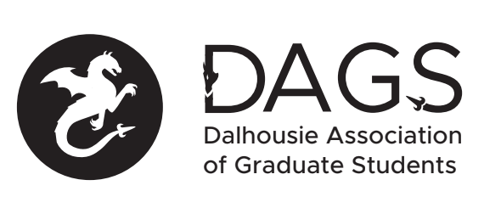

Local 113 of the Canadian Federation of Students
Council Meeting: Wednesday December 22rd 10:00 AM via Microsoft Teams
- CALL TO ORDER: 10:10 AM

- PRESENT: Sareen Singh- Community Health and Epidemiology Student Society; Ben Hansson- Student Senator; Ankit- DAGS President; Hariprashanth Deivasigamani- Faculty Rep Graduate Studies; Fatemeh Rahimi- DAGS DSCS; Pooyan Moradi - Health and Medicine; Raha Khosravi- VP DAGS; Soheil Latifi- DAGS VPFO; Jay Patel- DAGS VP; Office Coordinator.

- APPROVAL OF SECRETARY: Office Coordinator (Ankit/Fatemeh)

- APPROVAL OF AGENDA (Ankit/Raha)

- APPROVAL OF Previous DAGS COUNCIL MEETING MINUTES (Ankit/Soheil)

- OLD BUSINESS: None to discuss.

- NEW BUSINESS

  - DAGS Executive Updates
    - Ankit presented outreach poster with survey links, quarantine aid package, and ongoing travel grants.
    - Soheil elaborated on the quarantine aid package.
    - Jay presented upcoming events. Jay also met with a rep from Canadian Red Cross about helping DAGS with the quarantine aid package.
    - Fatemeh gave an update about the COVID support volunteer forms and will be connecting students soon.
    - Asal gave an update.

  - Senate Caucus Updates
    - Ben gave an update. There have been three senate meetings since the last DAGS council meeting, regarding: support for BIPOC students; legal action against Chegg.com; the pass/ill grading option vote; enrolment and budgetary losses; filling the open provost position; surveys on student health; grad student enrolment; industry engagement; OCRA; budget advisory committee 2021/22.
    - Ankit asked to clarify the Chegg.com legal action issue, and whether there would be tuition increases due to loss of enrolment.

  - Senate Feedback Winter 2021
    - Is anything that DAGS would like to bring forward to the Senate next term?
      - No response
    - Are there existing DAGS initiatives that could benefit from increased Senate engagement?
      - No response

  - DSU Graduate Rep Updates
    - Hariprashanth shared an update regarding the DSU emergency bursary; the pass/ill grading option; responses to allegations and support for survivors of sexual violence, harassment or discrimination; TA and markers; Ask DAGS initiative.
    - The Ask DAGS initiative was further discussed.

  - Approvals for Research and Travel Grants / Honorariums
    - Mahbubur Rahman Travel Grant
      - Approved unanimously.

  - DAGS Quarantine Support Package
    - Soheil gave a summary.
    - Approved unanimously.

- ANNOUNCEMENTS
  - Christmas Eve Online Meet-up

- ADJOURNMENT: 11:05 AM (Ankit/Fatemeh)

Minutes approved at meeting date: ______________
Moved by:____________
Seconded by:_____________

